Lab_Day-7 ANP-C9180 (For Loop)

1. Print the first 10 natural numbers using for loop

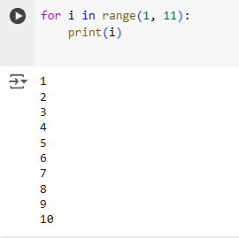

1. Python program to check if the given string is a palindrome

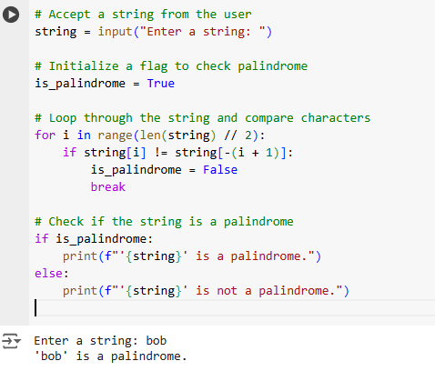

1. Python program to check if a given number is an Armstrong number

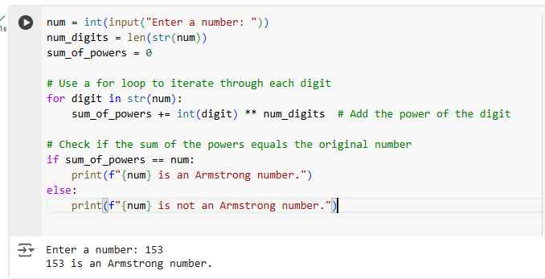

1. Python program to get the Fibonacci series between 0 to 50

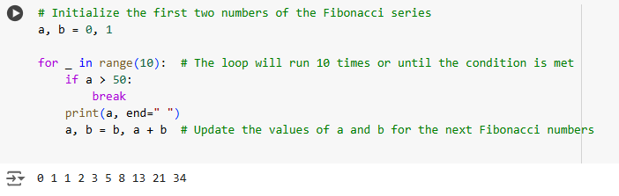

1. Python program to check the validity of password input by users

